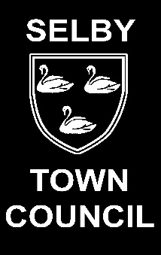
Selby in Bloom Competition 2025

SPONSORED BY THE SELBY TIMES AND
THE BIG COMMUNI-TEA

ENTRY FORM

- Residents supporting Nature Recovery

- Businesses, including Charities and Schools supporting Nature Recovery

- Allotments supporting Nature Recovery

The Selby Town Council Environment Committee as part of its commitment to enhancing the Town and improving the environment, are inviting entries for the above categories.

Prizes will be awarded for the winners of each category.

COMPETITION CATEGORY

Please tick the competition you are entering:

Residents

Businesses/Charities/Schools

Allotment

Site/Plot ………………………………

Closing date: Thursday 12th June
Judging will take place w/c 30th June.
Presentations will take place w/c 7th July at the Town Hall.

Name……………………………………………………………………………...

Address ………………………………………………………………………….

…………………………………………………Tel..……………………………..

Email ……………………………………………………………………………..

RULES

1 Premises/Allotments must be in the Town of Selby (see white area on the map below).
2 You can enter your own or nominate a friends or neighbours garden/allotment/ premises.
3 Nominations will be judged by photographs submitted along with an entry form.

PLEASE RETURN THE FORM AND PHOTOGRAPHS TO THE TOWN HALL, YORK STREET,SELBY, YO8 4AJ or Email admin@selbytowncouncil.co.uk

GUIDELINES

Judges will be looking for:

Residents, Businesses and Allotments that are supporting Nature Recovery and the Environment.
We would like to encourage the residents of Selby to support the Bees and other wildlife that are key pollinators. This can be done by planting flowers and creating places for wildlife to form habitats.
So whether you have a small flower pot with flowers that the bees enjoy, an insect hotel or a garden full of wildflowers – Everyone can join in!

