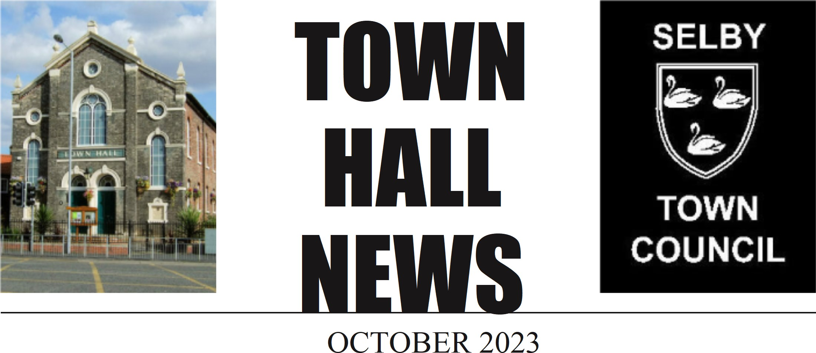

SELBY TOWN COUNCIL’S YEAR SO FAR
We are already six months into the current financial year, having held many successful events and ticked many items off our action plan we now are focusing on our Autumn programme of events along with setting the budget for the following year.
The council has achieved Foundation Level of the Local Council Award Scheme. The Awards are for local councils of any size and show that the council meets a series of tests; demonstrating that it is administered and managed as it should be. We are now working towards achieving the award of Quality Level. The Council’s Action Plan for 2023-2027 was published earlier this year. The plan is to ensure that operational decision making is transparent, and priorities are appropriately resourced. The Action Plan summarises our current responsibilities and the projects and proposals we will develop and/or deliver. This is a working document and progress will be reviewed at Committee meetings throughout the year, adding to it or amending as necessary. The Action Plan will inform the budget setting process and is available to view on our website Council-Action-Plan.pdf (exactdn.com)
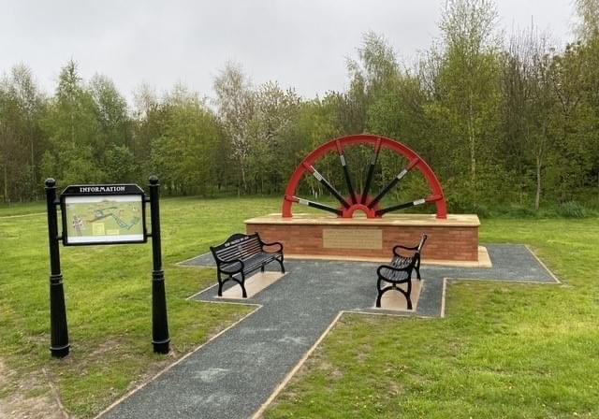
This year we have installed a memorial to the Selby Coalfield. The memorial is an original (half) wheel from a working coal mine. We had the wheel refurbished, painted, and mounted on a brick plinth. Each of the Selby Coalfield mines names have been engraved on metal plates and fixed on the spokes of the wheel. The memorial is located at the Bondgate Community Woodland and benches have been installed to enable people to sit, reflect and remember not only those who lost their lives but also those who came to join our community in Selby. The memorial was unveiled on 29th April, where past employees of Selby Coalfield gathered to listen to speeches and memories from guests including the Mayor of Selby Cllr W Nichols, and a blessing was given by Canon Weetman.
The Miners Memorial compliments the “Sailing Through Time” sculptures housed in the Town Hall gardens. The two sculptures commemorate the links to our waterways and the history of the shipbuilding industry which was based in the town, particularly Cochrane Brothers, which was famous for their sideways launching of the ships.
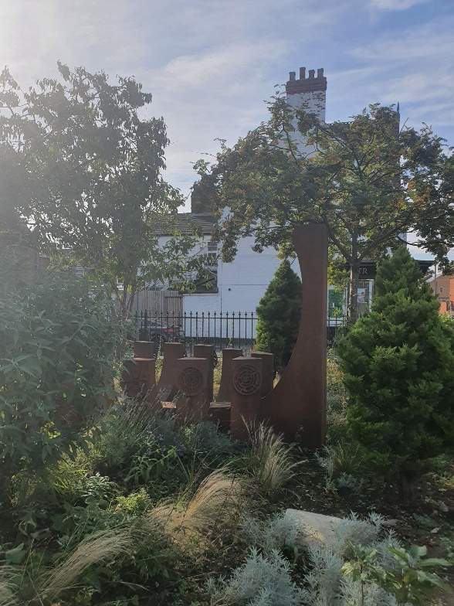
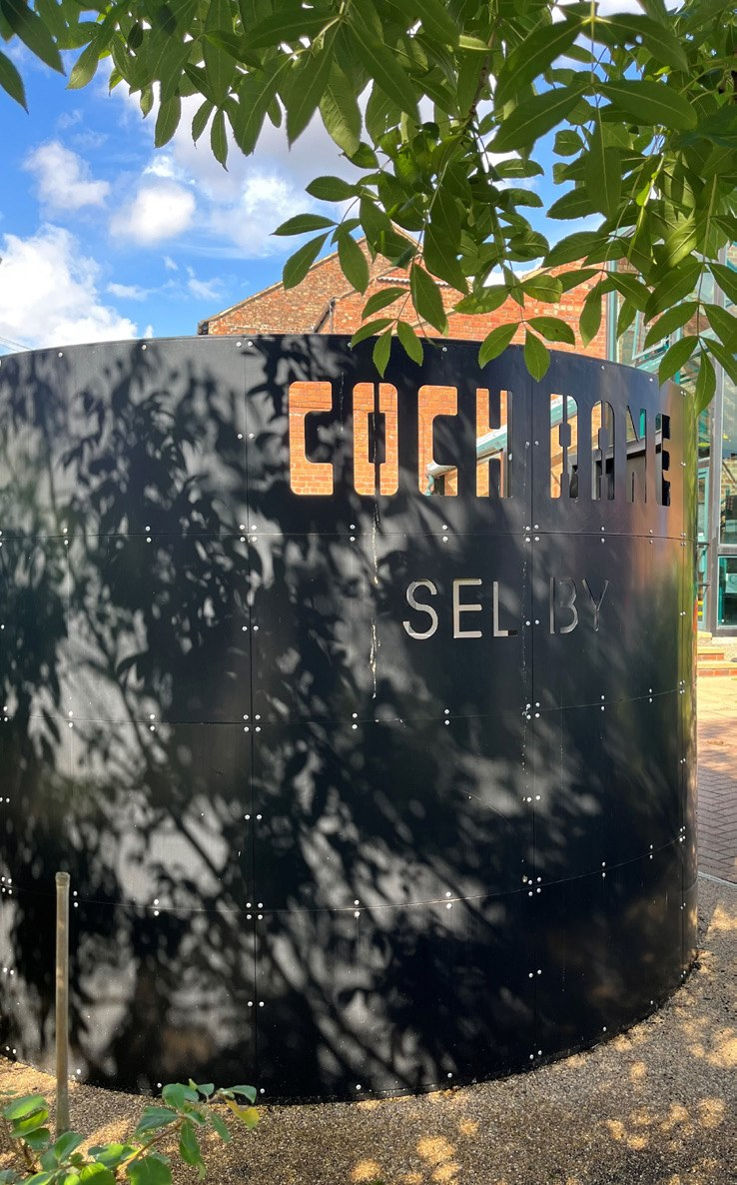

PAST EVENTS
Family Fun Day This year’s event was held on Sunday 25 June. It was a great success and was very well attended. Families enjoyed the free rides and games at the Scott Road Community Centre as well as the live bands on the Recreation Field. Many children joined in the events held in Selby Park by the Vale of York Athletic Club while the live music on the bandstand was enjoyed by all. Don’t forget to put next year’s date in your calendar: Sunday 23 June 2024.
Food & Drink Festival Held on Saturday 23 September visitors were able to purchase a huge variety of food and drink to take away, as well as to be consumed at the event, whilst enjoying the live music all day. The date of next year’s event is Saturday 13th July 2024.

FUTURE EVENTS
Bonfire and Fireworks Event Saturday 4 November on Scott Road Field
Cemetery Remembrance Service Friday 10 November in Selby Cemetery at 10.50am
Remembrance Service Sunday 12 November in Selby Abbey.
Everyone is welcome to attend both of the Remembrance Services and we will be very pleased to see you
Christmas Market and Lights Switch-On Saturday 2 December on the Market Place
Please follow @SelbySpecialEvents on Facebook to keep updated of all our events or check out our website www.selbytowncouncil.gov.uk

SELBY TOWN HALL
Have you visited our award-winning performing arts centre. This intimate venue, with a seating capacity of up to 150, hosts world class performances from national and international touring acts across a range of art forms including music, comedy, and theatre.
Our very successful Comedy Network Night is continuing, featuring the best new talent in the UK.
Excellent deals available when you purchase tickets for additional events
Details of upcoming shows and performances are available www.selbytownhall.co.uk

SELBY TOWN HALL ROOM HIRE
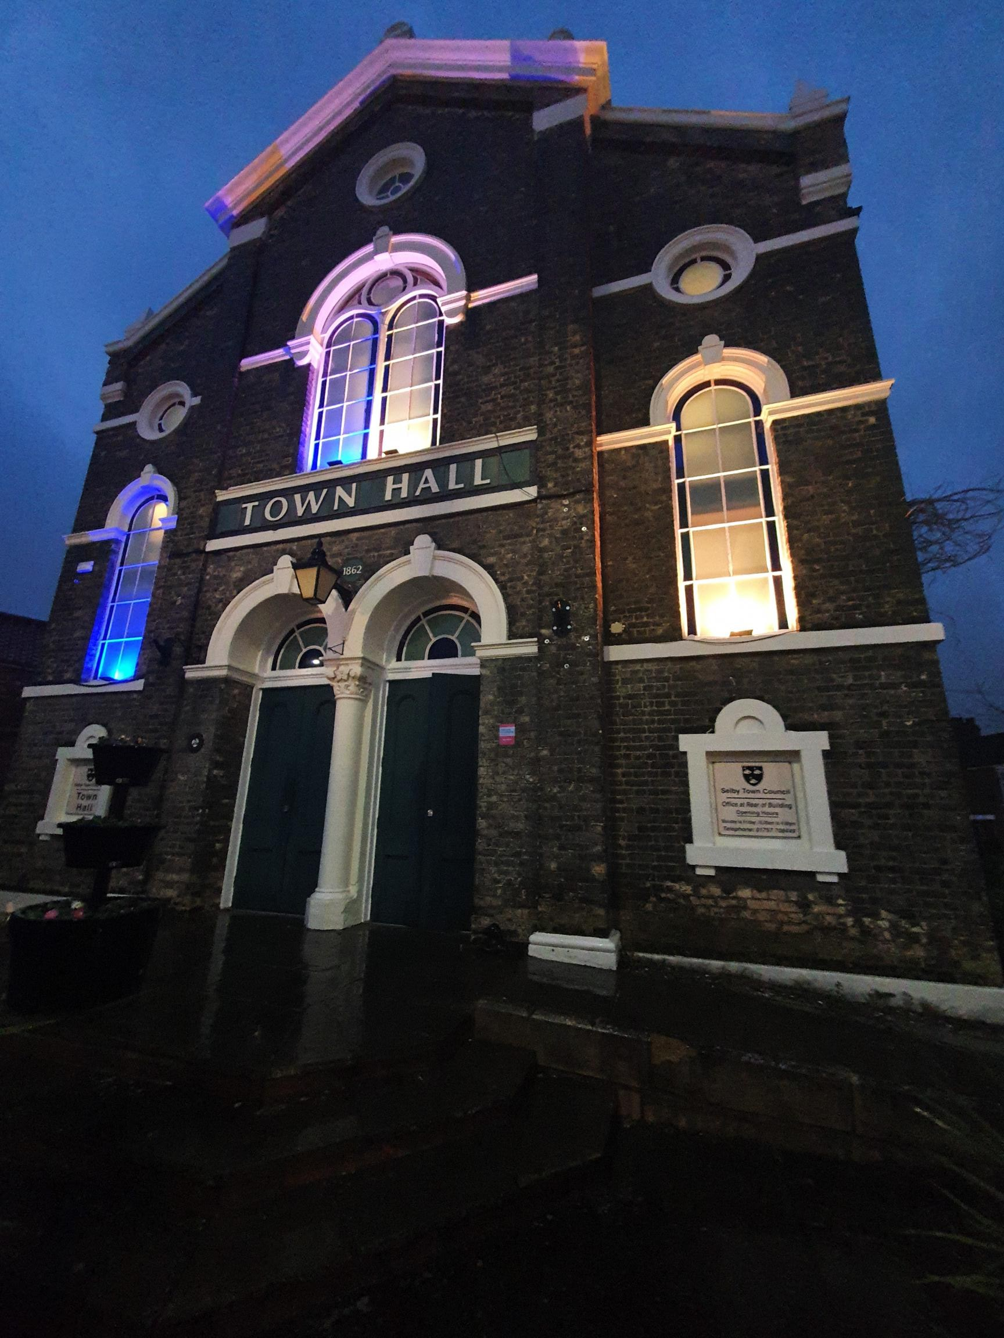
The Town Hall is a licensed wedding venue. The intimate venue is the perfect backdrop for you to create a unique, elegant, and unforgettable day for you and your family and friends. Our dedicated wedding team are here to advise and guide you from the moment you book your wedding with us, until you leave as a married couple.
Contact one of the team at admin@ selbytowncouncil.co.uk to arrange a show around of our facilities.
Whether you are wanting your ceremony, reception or both- we have spaces to cater to whatever you need.
Download our wedding brochure here: Wedding-Brochure.pdf (exactdn.com)
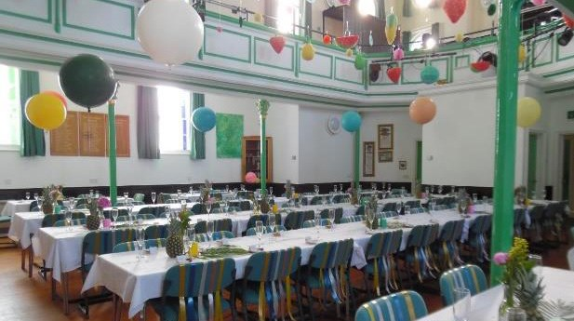
The Town Hall Art’s centre and studio are both available to hire for meetings, parties, and events.
Please contact the team at admin@selbytowncouncil.co.uk for current prices and availability.

ALLOTMENTS
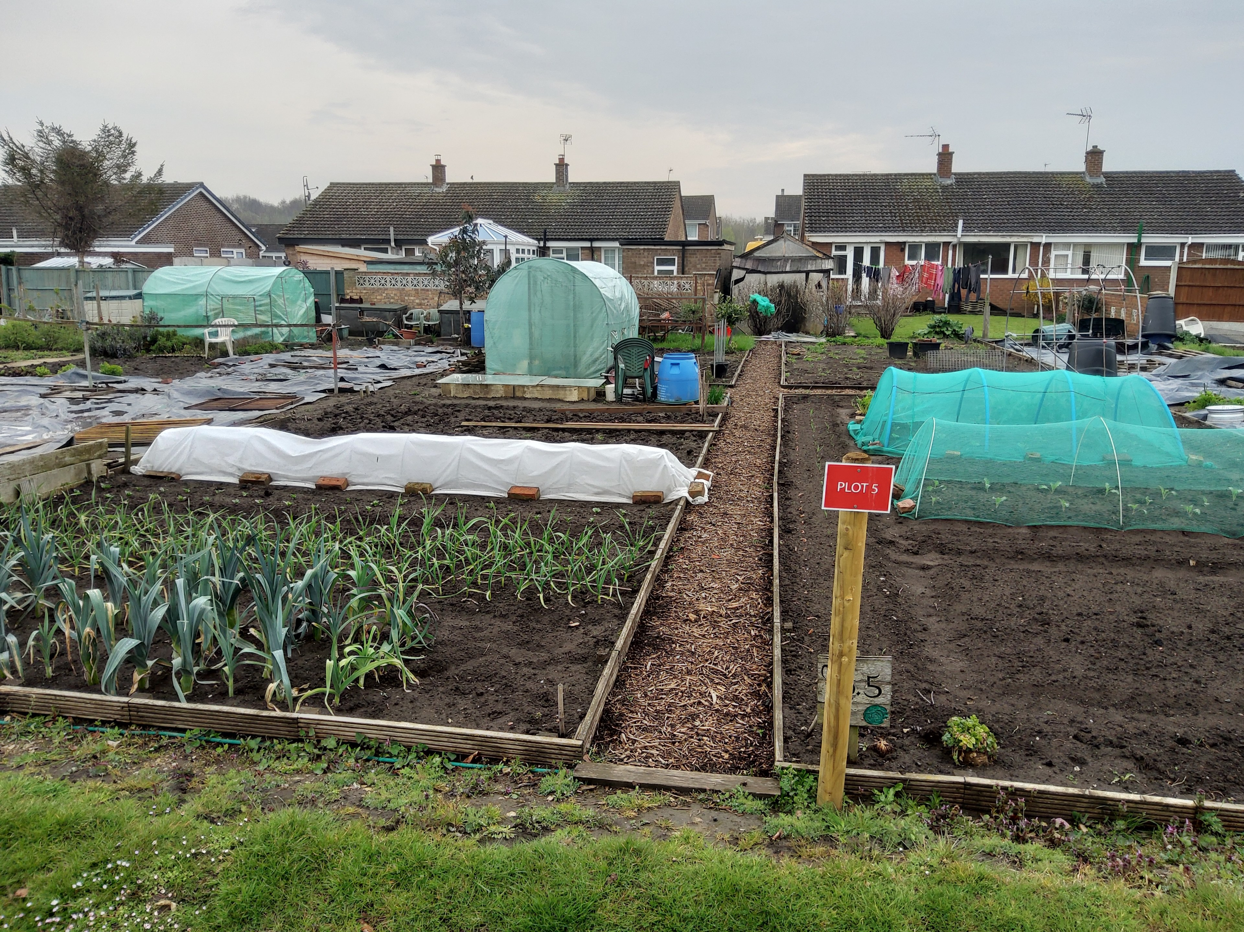
There will be a few allotments available, after clearance works, in the New Year.
To be added to the waiting list please contact the team at the Town Hall on admin@selbytowncouncil.co.uk
Allotments - Selby Town Council

ROAD SAFETY
We have received numerous concerns from residents about speeding, illegal parking and other road safety issues throughout the town. We take all these concerns very seriously and raise them with the relevant authorities. Illegal parking has become a big issue throughout the town, and we are arranging a meeting very soon with the Traffic Enforcement Officers to highlight the problem areas that have been identified to us.
Speeding in the community – you can find out how to report speeding concerns on the North Yorkshire Council website www.northyorks.gov.uk or click Speed limits, speeding, and road safety concerns | North Yorkshire Council

THE TOWN MAYOR
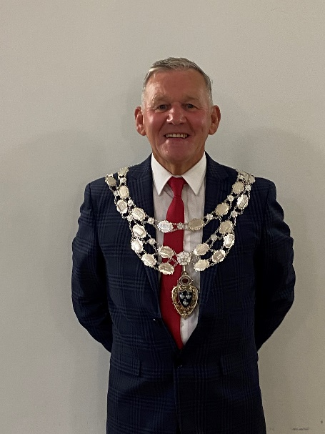
We elect a mayor, from our current Councillors, every year at our Annual Meeting held in May .This year Cllr Keith Franks was elected at the Annual Council meeting held on the 22 May 2023
Cllr Franks has lived in Selby 32 years after relocating with his family in 1981 whilst working at Wistow Mine.
He has been a Member for Selby Town Council since 2019, but was previously a Member from 1996 to 2004 and was Mayor in 2000/2001.
The Town Mayor in Selby is a civic role and the Mayor represents the Town Council at many events throughout the year. So far this year the mayor has represented the town at the Yorkshire Day held in Rotherham, planted a tree - donated by Selby Soroptimists Society for the Queens Platinum Jubilee, and attended a concert at Portholme Church to raise funds for the Alzheimer’s Society.
The Town Mayor will also be representing the town at the Selby-Carentan 50th Anniversary celebrations and a Miners Memorial Service in Sheffield.
Keith enjoys cycling, walking and DIY.

YOUR TOWN COUNCILLORS
Selby Town has 4 electoral wards:
Selby North
Cllr G Lockley(Lab)
Cllr R Harrison(Lab)
Cllr F Matthews(Lab)
Cllr S Shaw-Wright(Lab)
Cllr K Franks (Lab)
Selby South
Cllr S Andrew(Lab)
Cllr H Davis(Lab)
Cllr T Beharrell(Green)
Cllr J Proud(Lab)
Cllr W Nichols(Lab)
Cllr M Davis(Lab)
Selby West
Cllr K Arthur(Con)
Cllr G Jordanowski(Con)
Cllr M Dyson(Con)
Cllr M Lawton(Con)
Cllr L Lawton(Con)
Cllr C Laskey(Lab)
Selby James’
Cllr J Shaw-Wright
You can find out who your Councillor is and their contact email and telephone number on our website:
Meet Your Councillors - Selby Town Council
Information regarding your representatives on North Yorkshire Council can be found here:
Find Councillor | North Yorkshire Council

CURRENT SERVICES DELIVERED AND MANAGED BY SELBY TOWN COUNCIL
We do provide some direct services to the public, but we are a relatively small organisation. We are lucky to have a passionate, dedicated, and skilled staff group, led by our Town Clerk. It is they that provide us with the capacity and capability to carry out our responsibilities.
We are responsible for:
• Town Hall & The Art’s Centre Programme
• Markets – Weekly and Monthly Farmers Market
• 1811 Building
• Family FunDay, Bonfire & Fireworks
• Cemetery and Chapels Cemetery - Selby Town Council
• Specialist Markets and Events
• Longmann Hill’s Farmhouse (Private let)
• Selby in Bloom – Hanging Baskets & planters
• Cemetery Lodge (Let to a staff member)
• Some Street Lighting and furniture
• Play Areas x 3 Play Areas - Selby Town Council
• Annual Remembrance Event and Cemetery Remembrance Service
• Allotment sites x 3
• Christmas Lights & Switch-On Event
Manage and support Selby Community Trust which includes Scott Road Community Centre, Community Land, Community Pond, and Bondgate Community Woodland
And we continue to assess Town Council services with a view to reducing our carbon footprint wherever we can.CONTACT US
Our website provides information regarding services such as allotments, cemetery, and markets as well as updated event details. You can also contact us through the website www.selbytowncouncil.gov.uk/contact
Tel: 01757 708 449
Email: admin@selbytowncouncil.co.uk
Twitter: @SelbyTC
Facebook: @selbytowncouncil

USEFUL CONTACTS & LINKS
North Yorkshire Council: 01609 780 780 Home | North Yorkshire Council
Services include:
Council tax | North Yorkshire Council
Benefits | North Yorkshire Council
Bins, recycling and waste | North Yorkshire Council
Education and learning | North Yorkshire Council
Housing and homelessness | North Yorkshire Council

Emergency Homeless: 0300 131 21 31 Out of hours/weekend: 01653 600941
Domestic Abuse: 03000 110 110 www.idas.org.uk
Children at Risk: 01609 780 780

